OOSD (COMU218) 2008 coursework – teamwork document

Team name and members: Team-C "An RPG written in Python"

Alasdair Morrison
Alexander Clowes
John Walls
Jordan Holmes
Aaron Lafferty

Note: We sometimes used each others svn accounts because we were pair programming and doing it at the same time. So although some svn account will seem like more contribution than others it was a group effort.

Contents

1 Specification 2
2 Design 2
2.A Basic version 2
2.B Advanced version 2
3 Project plan 2
4 Release one 2
5 Release two 2
6 Appendix 1 – Project management and Teamwork 2
7 Appendix 2 – Code 3

Specification
The RPG will be a classic turn based random encounter RPG. The company logo will be shown, and then the scene will be set by rolling text at the start. After this the menu screen shall be shown. The player will be given the choice whether to play or quit. If the player chooses play then the game starts. The main character will walk around a world map fighting monsters which appear randomly. The player will then locate the first boss, fight it, and the demo will end. The battle system will work on the method that each enemy has a health bar with . Once the enemy has taken this number of hits they will succumb. The main hero will have a starting health of 100. Each enemy will be able to harm the player within a range of numbers e.g. one enemy may hit the player for a number of damage between 3 or 5. The user can press enter to bring up a menu at any time where they have the option to quit the game.

Specification:
Main scene:
- The player must be able to move in 8 directions using arrow keys
- Random battles must happen randomly
- Non player characters conversation
- Collision detection
- Show background image
- Dialog system
- Initiate boss battle at specific place
- Exit when closed
- After boss dies end game
- The scene must follow the player around the screen until it reaches the end of the screen
- The player should not be able to move outside the screen area
- Player must be able to move behind buildings as well as in front of them.
- Player must be able to change image depending on what direction they are travelling in

Battle:
- Must be able to attack
- Enemies must be able to attack back
- Option to flee (certain chance)
- Get experience from battles
- Lose health from damage
- Attack and defence system utilised to count damage
- Must be different levels of enemy
- Boss battle required
- Dialog system
- Show health
- Show both player and enemy on screen
- Show menu
- When player dies bring up start menu
Splash screen:
- Show pictures in loop
- After player input goto menu
House:
- No random battles in house
- Player must be able to move around house
- Player must collide with tables and the edge of the screen
- The screen follows the player around the screen
- Returns to main screen when walks out door
Menu:
- Option to exit
- Option to start game
- Option to see credits
- Option to see help

Design
We have hard copy sketches that will show how we designed the game.
Class diagram:
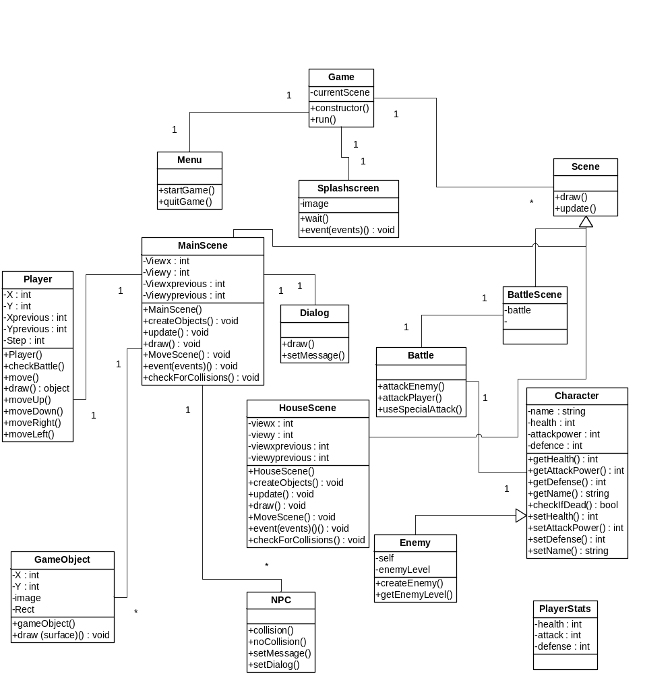
Sequence diagram:
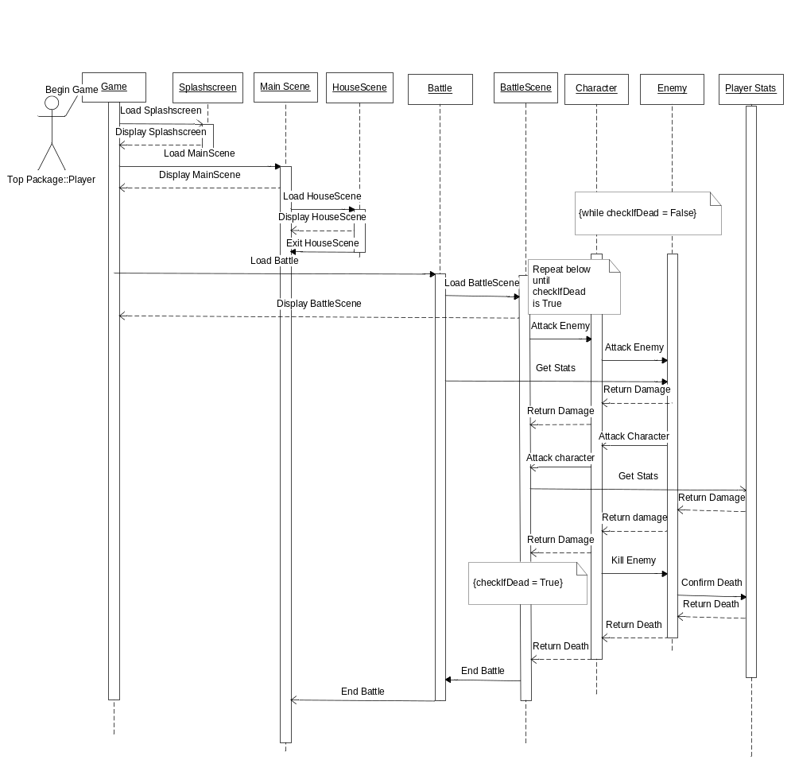

Basic version
In the basic version, all that we wanted to accomplish was a graphical representation of an overworld with battle mechanics in the background. This was accomplished very well. Also in the basic version John’s code was to be created, albeit too simple for the finished product. Ali would make the main scene and Jordan would create the battle mechanic. A menu was wanted to be created was made by Aaron, but with no events.

Advanced version
In the advanced version we would apply graphics to our battle mechanics, courtesy of Jordan. Also, Alex was to make an indoor scene to allow different screens to be displayed onto the game. John’s code would be animated as to make it accomplish more. Aaron’s code were to be given events and Ali’s code now allowed the battle scene to be launched at random intervals, NPC’s would now be able to converse with the hero, and the main scene will be completed to specification

Project plan
This section plans what tasks are going to have to be done for the project, and details who will do which ones.
(Everybody should be kept reasonably active throughout the project, and evenly – minimise the amount of time that some people have to wait around for, while others complete their tasks.)
Give details of how the project is to be managed (including meeting times, online and face-to-face).

Each member of our team has decided with what they wish to accomplish through our creation of the game. Alasdair is creating the main play area as well as the player. Aaron is creating the menu class with which the main game will interact with before entering. A splash screen created by John will show the company logo to the player before the menu is called. Jordan is creating the battle system which will be called by the main play area at random intervals, simulating random battles. Alexander is creating an house scene which will show a small example of the inside of a house.
Splash Screen(John)
Menu(Aaron)
Main play scene (Alasdair)
Battle scene(Jordan)
house scene (Alexander)

John’s program will be quite a simple one which calls 3 images, plays them on a loop, and continues to do so until a key is held by the player to terminate this loop. Instead of doing most of the code, John will be taking all of the documentation created and organising it into the final report.
Ali’s program will consist of 7 classes, as he is the most adept with the programming language. The main class of these will be the game class which calls all of the other classes into it to produce the game on screen. Within it, John’s code is called and then the rest of the classes are called, one of them being Main Scene. The Main Scene class is where a majority of the graphical rendering will happen, with the background image being called, the graphical representation of movement being made, the boundaries will be set and the Player class shall be called to render the player into the Main Scene; this will be accomplished by four sprite images facing up, down left and right, with the appropriate key press moving the screen around the player, signifying movement. The Scene class is where each scene in the game calls to get the draw and update methods. The dialog class will allow the main scene to display-when an NPC is approached-a text bubble. The NPC class will be there to detect when to initialise this dialog class.
Jordan will be working on 5 classes for our program as he has a strong history with coding. His code will focus primarily around the Battle class. The Battle class will be where the other classes for the battles will feed into. Character is one of these classes, simply holding all of the statistics of the player. The Enemy class is similar to this, although the enemies will have set values to their statistics. The Battle Scene class will display all of these In a nice looking GUI, with visual place holders for Character and Enemy.
Aaron’s coding will revolve around the creation of the menu screen that appears after John’s image loop. It shall have two options on it which are to either select to play the game or to quit the game. The complication which will come through his programming will be the inclusion of a select method due to buttons on the screen.
Alex’s coding will work very similarly to Ali’s code but instead of the main scene Alex will be coding an indoor House Scene. This will allow our program to show smooth transitions between sets of codes. Our meetings will be once weekly worked on a method of seeing where we get to by the end of each week and then noting down what needs to be done for the next week.

Our group will use the labs to conduct the meetings as well as communicate online through social networking programs. Also we used other meeting times for other courseworks to make sure we were on track for the project.

Release one
This describes the first (basic) system. What does it do; how much of it works, and what bugs or other problems remain in it? Include screenshots by all means.

Release 1 achieved most of the goals set out in the specification for the game and achieved all goals and more for the release 1 specification.

Splash screen

Done
Splash screen is shown for 3 seconds and disappears leaving a black background.

Still to add for next release
Splash screen is animated so it changes images

Main scene
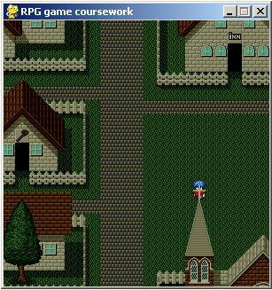

Done
The character moves in all 8 directions and the image changes to reflect the direction they are travelling in.
Random battles do not happen randomly but every 10 presses of the keyboard keys. So a future release (release2) should make the random battles actually happen randomly.
Collision detection works for all buildings, the main game boundary and the water.
The player can move in front of and behind building depending on their location.
It shows the background image which will represent the town where the main scene is played.
The view follows the player around the screen until it reaches the end of the screen.
The game exits when the Esc key is pressed or the cross is clicked.
The player cannot move outside the main game area.

Still to add for next release
Non player characters must exist
Players must be able to initiate conversation with npc
Dialog system must be created for conversation and other dialog
Random battles must happen randomly rather than after 10 key presses
Must initiate boss battle when player reaches boss area
Must be able to call the House and Battle scenes

Battle scene

Done
The battle works but only text based.
The character and enemy objects can attack each other

Still to add
Graphical representation of the battle
Menu to select move
Wait for player to attack
Different levels of enemy

House scene

Done

Collisions work so the player can’t move out of the screen
The player can move around the scene
The view follows the player around the screen
It shows the correct background image of a house

Still to add

Set proper player position, instead of using default
More collision so the player doesn’t walk over the tables
Remove unwanted areas from the background image

Menu

Done

Image created to display the menu

Still to add

Events to determine where the program goes

Release two
Release 2 managed to achieve all the goals set out in the original specification.
Splash Screen
The splash screen is now animated and works well with the rest of the game. The splash screen is complete.
Main scene

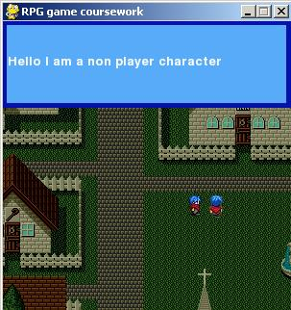

The main scene now initiates all the other scenes such as house and battle scenes.
Players can now initiate conversation with npcs by walking into them
Dialog system now exists and works when talking to npcs
Random battles now happen randomly
The main scene is now complete to the original specification.

Battle scene
Battle scene is now graphics based
Battle scene now takes user input
It now goes back to main scene when enemy dies

House scene
The House scene now manages to go back to the main scenes when the player moves out the door.
The player is now created in the correct position.
Tables now collide with the player
The house background has been improved to hide unwanted objects.

Menu
The menu is created after the splashscreen
It displays the image made for release 1
When enter is pressed the game loads and when escape is pressed the game terminates before initialising

Appendix 1 – Project management and Teamwork
Include notes and minutes taken from meetings here, including any major decisions made about changing the course of the project as it progressed, because of any problems encountered etc.
This section should be agreed by all team-members as an accurate description of how the team worked together. Any individual differences in views should be expressed elsewhere, in the "private reports" which are to be handed in separately.

Week one:
In the first week it was decided within our meeting that the genre of game we were going to create was an RPG. After this, we drew up a sequence of events in the form of a mini-storyboard drawn on paper. The events were as follows: a splash screen showing off the company logo followed immediately by the start of the game, the player would be able to move around an overworld style map, battles would be fought, a boss battle would be fought, and then the game would end. It was then decided that the programming language we would use would be Pygame as it offered us more than the regular python engine did.

Week two:
By week two we had a few classes typed up and working together to create a small program of a sprite moving around on an image. It was at this point that we realized we had yet to document any of these decisions. Alasdair started to write them up into a word document whilst John got a very shallow start on a sequence diagram on the battle system. We all decided that it would be beneficial to our program if we did the documentation in parallel with the creation of the program. That way as soon as a decision was reached it would be able to be coded into the program quicker than designing the whole project and then coding it. It was here that we each decided what we all wanted to do as well. Ali continued the coding for the main overworld. Jordan decided he wanted to code the battle. John chose to code the splash screen, as well as try to animate it in some way. Aaron chose to code a menu and Alex asked to code an indoor scene.

Week three:
We decided to use this week to check on the progress of each of these programs. Ali’s main scene programming had come on quite a bit as now the image had boundaries. The battle scene that Jordan was working on was being created nicely; it just had yet to be given graphics. Alex and Aaron’s codes were still in the planning stages and John’s program had been created to display an image for 3 seconds and then terminate. We decided that for the next week all that we had coded so far would have to be written up into a class diagram as well as fleshing out the sequence diagram. As well as this, we decided that John would take his image and try to animate it in some way, Ali’s code would need to load an image which signified depth as in its current iteration the player was hitting boundaries, yet as he passed by a building the sprite looked as if it was in front of the building from behind. Jordan’s code simply needed some fine tuning as well as a battle scene created with graphics. After the planning for what was required from the menu and the indoor scene that Aaron and Alex were creating respectfully.

Week four:
As this was the week that release one was to be created for, we all decided to take each of the bits of code that we had and implement them. At first this implementation was rather difficult for John and Ali were using different methods within Pygame to call images. This made it impossible for Ali’s code to call the splash screen class that John had created. This was an easy fix though and after this we had a release one. It was a program which ran the splash screen and then loaded up the code for the game. The player was able to move in 8 different directions on the screen and detect random battles. However, since there was no collaboration yet between the battle scene classes and the main scene classes, all that the program did was display random battle at periodic intervals. For release two we wanted a battle scene to be created, the indoor scene and the menu screen to be created to give the program a more professional feel. The sequence diagram which was started to display the workings of a battle was scrapped in favor of a sequence diagram which would display the workings of a play through of the game. Also, the newly created classes were added to the diagram by John and Ali stated he would write the documentation for release one.

Week five:
In this week is when a lot for our program got done. Alex had created his indoor scene and the battle scene was created. The menu was also coded up and the splash screen had an inkling of animation to it, with three images played on a loop until enter was held down to end it. We all agreed that we were happy with each other’s work. This was also the week where the second release was, well, released. It worked like thus: The splash screen class was called and ran until the player held down the enter key, as they were prompted to do. After this, the menu screen appeared giving the player the choice to play the game or to quit. When the player chose play they were brought into the main scene, within it they were able to walk around a realistic looking world which had depth and boundaries. As a random battle was found, the battle classes were called to display a working battle, giving the player the option to attack, use a special attack or flee. The player then walked into the inside of a building learning of the boss from an NPC. The boss was found, defeated, and then the game terminated. The player was allowed to terminate the game at any time using the escape key. All in all, in this meeting we liked the program with which we made, just needing to polish up the documentation in order to hand in our finished product.

Appendix 2 – Code
Partial code listings (or even full code listings if not excessively long) should go here.
The chief programmer(s) responsible for each file should be named at the top the file.
Don't forget to include comments in the code, in the form of comment lines and / or docstrings.
Also include any unit tests that are at the end of code files.

Aaron Lafferty:
import sys, os, pygame
from pygame.locals import *
from Scene import Scene

class menuScreen(Scene): #Menu class for the menu screen
def __init__(self, width=300,height=300):
pygame.init()#starts pygame
self.width=width#sets width of window
self.height=height#sets height of window
self.background=pygame.image.load(os.path.join("images","menuScreen.jpg"))#loads the image ready for use
self.screen=pygame.display.set_mode((self.width,self.height))#displays the screen
def draw(self):
self.screen.blit(self.background,(0,0))
def update(self):
u=1

def event(self,events):
"""
Handle all input events here
"""
for event in events:
if event.key == K_RETURN:#starts the game
self.game.gotoMain()
#print "r"
if event.key == K_ESCAPE:#quits the game
sys.exit(0)

John Walls:
import sys, os, pygame
from pygame.locals import *
class Splashscreen:
def __init__(self):
pygame.init()
background = pygame.image.load(os.path.join("images", "stein1.jpg")) #imports the image to display
size = width, height = 300, 300 # sets screen dimensions
screen = pygame.display.set_mode(size) #creates screen
pygame.display.set_caption('RPG game coursework') #gives the program a title
screen.blit(background, (0, 0)) # imports background into screen
pygame.display.update()
pygame.time.wait(1000)#screen displays for 3 seconds
background2 = pygame.image.load(os.path.join("images", "stein2.jpg"))
screen.blit(background2, (0,0))
pygame.display.update()
pygame.time.wait(1000)
background3 = pygame.image.load(os.path.join("images", "stein3.jpg"))
screen.blit(background3, (0,0))
pygame.display.update()
pygame.time.wait(1000)
splash = Splashscreen()
running=True
print "please hold down the space bar to load the menu"
while running:
for event in pygame.event.get():
if event.type == KEYDOWN:
if event.key == K_SPACE: #if wanting program to terminate hold
running= False #space bar down

splash = Splashscreen()

Alasdair Morrison:
def checkForCollisions(self):
"""
This method checks the player rectangle against all game rectangles
This is called everytime the room is drawn
"""
playerrect = pygame.Rect(pl.x,pl.y,18,24)
houserect=GameObject(192,352,"",pygame.Rect(255,400,256-255,403-400))#collision for a building (eating place)
if (playerrect.colliderect(houserect)):
self.game.currentScene=HouseScene()
self.game.currentScene.game=self.game
pl.y=pl.y+20
pl.vspeed=0
self.viewy=self.viewy-20
self.viewvspeed=0
i=0
while i<len(self.objects):

if playerrect.colliderect(self.objects[i].rect) == 1:
self.viewx=self.viewxprevious
self.viewy=self.viewyprevious
pl.x=pl.xprevious
pl.y=pl.yprevious
self.objects[i].collision()
else:
self.objects[i].nocollision()
i=i+1

Alexander Clowes:
def createObjects(self):
"""
Create the housescene game objects and puts them into the objects array,
this should be called at the start of the scene. In here are the
collision blocks used for the walls and the tables in the building.
"""

self.objects = [GameObject(0,0,"",pygame.Rect(0,0,300,50))]
self.objects.append(GameObject(0,0,"",pygame.Rect(0,0,26,226)))
self.objects.append(GameObject(0,0,"",pygame.Rect(0,236,71,53)))
self.objects.append(GameObject(0,0,"",pygame.Rect(105,235,58,54)))
self.objects.append(GameObject(0,0,"",pygame.Rect(151,151,12,76)))
self.objects.append(GameObject(0,0,"",pygame.Rect(27,42,77,92)))
self.objects.append(GameObject(0,0,"",pygame.Rect(163,152,125,4)))
self.objects.append(GameObject(0,0,"",pygame.Rect(275,0,11,156)))
self.objects.append(GameObject(0,0,"",pygame.Rect(42,176,12,8)))
self.objects.append(GameObject(0,0,"",pygame.Rect(122,176,12,8)))
self.objects.append(GameObject(0,0,"",pygame.Rect(170,112,12,8)))
self.objects.append(GameObject(0,0,"",pygame.Rect(170,64,12,8)))
self.objects.append(GameObject(0,0,"",pygame.Rect(234,64,12,8)))
self.objects.append(GameObject(0,0,"",pygame.Rect(234,112,12,8)))

